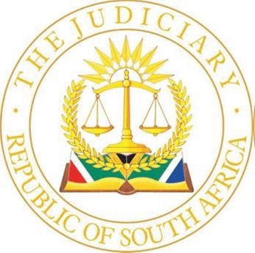
CHAMBERS OF THE HONOURABLE JUSTICE MALULEKA
HIGH COURT GAUTENG DIVISION PRETORIA
PALACE OF JUSTICE, 2ND FLOOR, ROOM 235
C/O PAUL KRUGER AND MADIBA STREETS, PRETORIA, 0002
TEL: +27 12 492-6900 / NoMbatha@justice.gov.za

26 September 2024

DIRECTIVE FOR THE HONOURABLE JUSTICE MALULEKA DEFAULT JUDGEMENT TRIAL COURT 30 SEPTEMBER – 04 OCTOBER 2024

- Matters will be heard in open Court at 10h00.

- Counsel may introduce themselves in court when calling their matters.

- Settlements, removals and postponements will be called first. Practitioners must inform Ms N Mbatha at NoMbatha@judiciary.org.za before 12h00 the day before the hearing date if any matter will not proceed so as to avoid papers to be read. A widely shared note to that effect must also be published on Caselines.

- Settled matters must have a separate bundle on Caselines with all required documents including the draft order.

- A separate section must be created on Caselines named DEFAULT JUDGEMENT which must contain the following:

  - Practice note

  - Heads of argument

  - Compliance affidavit

  - SIC (TIC) order

  - Proof of service of the SIC (TIC) order

  - Application for default judgment

  - Proof of service of the application for default judgment

  - Notice of set down of application for default judgment, with proof of service

  - Pleadings

  - Merits documents

  - Expert reports

  - Rule 38 application

  - Past medical expenses schedule (if applicable);

  - Contingency fee agreement (if applicable);

  - Draft order.

- Thereafter matters will be heard in order of seniority.

- Two hard copies of the draft order must be handed up.

