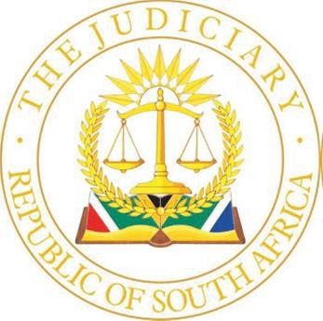
CHAMBERS OF THE HONOURABLE JUSTICE MOGAGABE
HIGH COURT GAUTENG DIVISION PRETORIA
PALACE OF JUSTICE, 2ND FLOOR, ROOM 235
C/O PAUL KRUGER AND MADIBA STREETS, PRETORIA, 0002
TEL: +27 12 492-6900 / NoMbatha@justice.gov.za

25 September 2025

DIRECTIVE FOR THE HONOURABLE JUSTICE MOGAGABE
DEFAULT JUDGEMENT TRIAL COURT 29 SEP - 03 OCT 2025

- Matters will be heard in open Court (as detailed on the day roll) at 09h30.
- Counsel may introduce themselves in court when calling their matters.
- Settlements, removals and postponements will be called first. Practitioners must inform Ms. N Mbatha at NoMbatha@judiciary.org.za before 12h00 the day before the hearing date if any matter will not proceed to avoid papers to be read. A widely shared note to that effect must also be published on Caselines.
- Thereafter matters will be heard in order of seniority.
- Two hard copies of the draft order must be handed up.
- The heads of arguments should be uploaded by 12h00 the day before the hearing date.

